Name: Akshat Bhargava

Rollno: TEAD-22563

DS (SL-III)

Practical 11

Problem Statement: Create databases and tables, insert small amounts of data, and run simple queries using Impala.

Code:

Pull the Impala Docker Image:

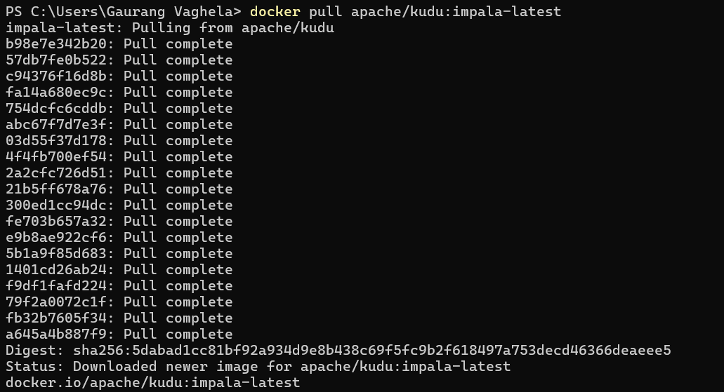

Run the Impala Container:



Access the Impala Shell:

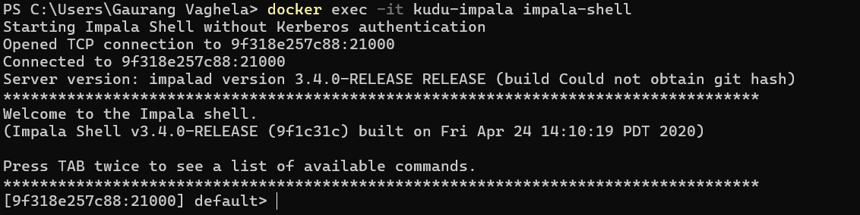

Show Databases:

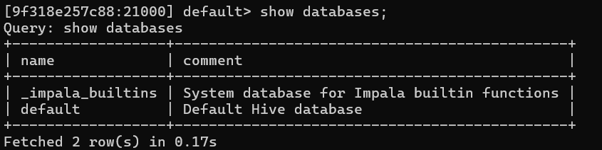

Create Database and Table:

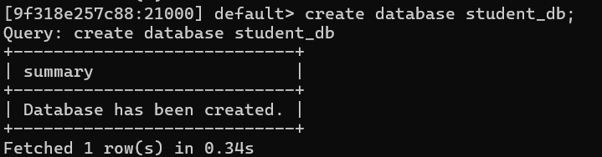

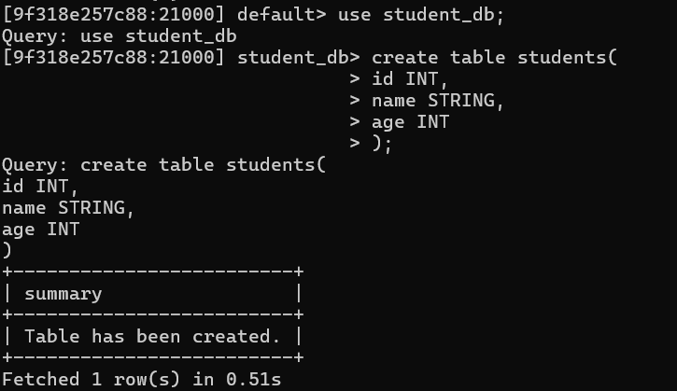

Insert values in table:

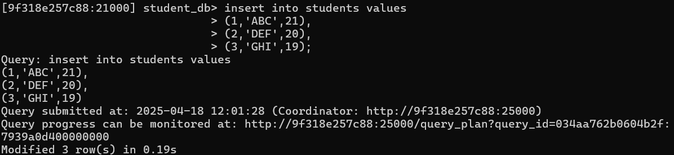

Display Table:

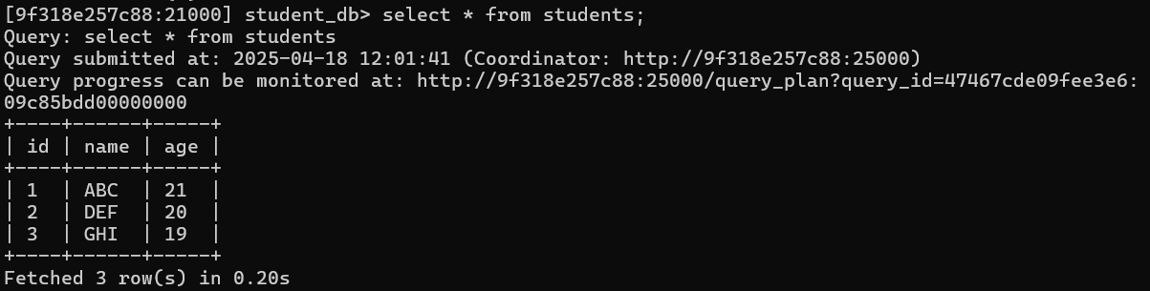

Display Students where age > 20:

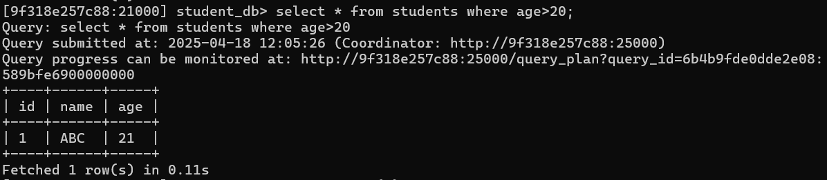

Display Avg(age):

